Request For Proposals
Seneca Harbor Marina Restaurant
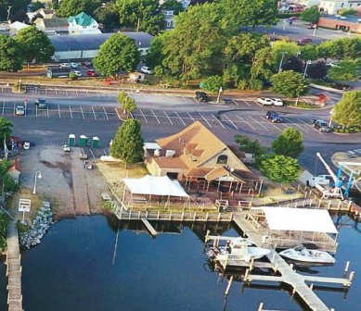

Schuyler County Industrial Development Agency in partnership with Schuyler County, is seeking requests for proposal (RFP) from qualified businesses for a one-year lease (2022) of the former Village Marina Restaurant site located on Seneca Lake in Watkins Glen, New York.
The Village Marina Restaurant was a well-known destination on Seneca Lake and has operated for over ten years. The building is approximately 2500 sq. ft. including a covered deck.
VILLAGE OVERVIEW
The Village of Watkins Glen is located at the headwaters of Seneca Lake and is considered the gateway to New York State’s Finger Lakes Region. The accessibility from major metro areas such as NYC, Philadelphia, Washington DC, Toronto as well as nearby cities of Rochester, Syracuse, and Erie, Pennsylvania, make the Village of Watkins Glen a prime location for developers and investors alike. The economies of Watkins Glen and Schuyler County rely heavily on tourism to and through the Finger Lakes Region. Recent tourism statistics estimate Schuyler County hosts over 3 million annual visitors drawn to attractions in the Village and surrounding area including Watkins Glen International Speedway, Cornell University, nationally-recognized Watkins Glen State Park, Seneca Lake, Corning Museum of Glass, and the Seneca Lake Wine and Beer Trails.
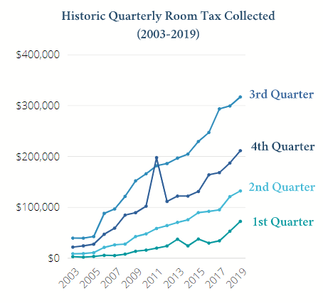
ECONOMIC GROWTH
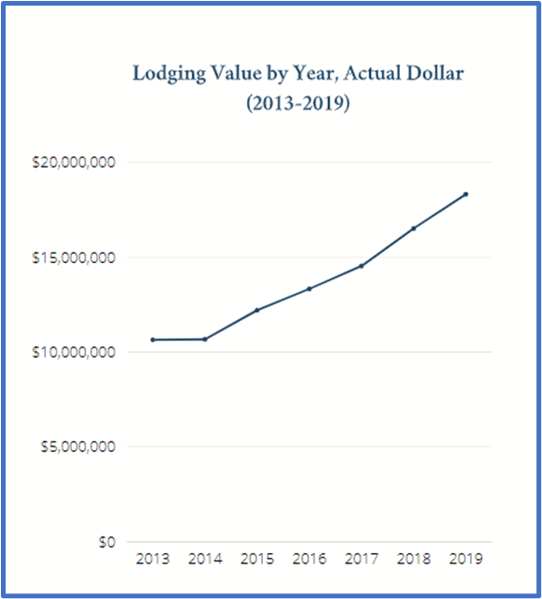
In 2012, Project Seneca Initiative was created to redevelop the Villages of Watkins Glen, Montour Falls as well as transform the waterfront in Watkins Glen. When the transformation is complete, investment is expected to total $400 million. Occupancy and sales tax revenues continue to set records year after year. GDP for Schuyler County is growing at a rate of 6.42% since 2001. Housing permits for new construction have grown by nearly two percent since 2014. Schuyler County ranked 8th in the State of New York for business growth in 2018 with an annual rate of 3.0%. Watkins Glen’s resident population grew by nearly 5% between 2015 and 2017 to a total of 1,919 while the median age has lowered from 43 to 38.

According to the 2020 cost of living index, Watkins Glen is 18.7% lower than the United States average. Schuyler County has experienced remarkable increases in both sales tax and lodging tax revenues since 2008. The county is achieving success in bolstering the year-round economy by an expanded tourism season that has increased over time as depicted in both figures.

Details:
The landlord is not providing any furnishings or equipment. The building is being leased as-is.
The desired operation is no less than 8 hours daily from April 16th through October 30th.
While there have been no concerns historically, it is important to note that the facility resides on designated parkland which allows the public to utilize any outdoor seating.
The building is adjacent to dock 5 which includes a large covered deck. The deck and enlarged seating area are private. Permission for the use of this amenity will need to be granted by the operator of the marina, Schamel Brothers.
The building is adjacent to the Seneca Harbor marina and houses the mechanicals (infrastructure) for the marina. It also houses the restrooms and showers for the marina tenants who have external access at the rear of the building.
The unaudited annual gross sales from the restaurant, over the past five years, range from a low of $867,998 to a high of $933,974.
Insurances are required and will be determined based upon usage. Both the Schuyler County IDA and Schuyler County will be named as additionally insured.

Submittal Deadline: 4:30 pm January 21, 2022.

Potential Tenants shall prepare a submittal including the following information:

Q1. Complete business name, business address, telephone number, mailing address, individual serving as the point of contact for the lease.
Q2. Length of Time in Business
Q3. Business and/or Services Offered
Q4. Dates & Hours of Operation
Q5. Proposal for Lease Terms
Q6. Licenses needed and schedule for obtaining a license, if necessary
Q7. Insurances obtained and schedule for obtaining, if necessary
Q8. Planned Programming for the Space
Q.9 Process and Limitations for Providing Access to Basement to Marina Mechanicals.

Submittals shall be sent to: Schuyler County IDA
910 South Decatur Street
Watkins Glen, New York 14891
Email: Judy@Flxgateway.com

