Schuyler County Industrial Development Agency
910 South Decatur Street, Watkins Glen, NY 14891
Meeting Minutes
December 8, 2021

Call Meeting to Order: The meeting of the Schuyler County Industrial Development Agency (SCIDA) was called to order at 5:00pm by Carl Taber.

Roll Call: | Hon. Carl Blowers  Carl Taber  John Terry  Margaret Lawrence  Mark Taylor  Kristin Van Horn  Laury Ward  Chad Hendrickson | Schuyler County Legislature  Chair  Vice Chairman  Treasurer  Member  County Planning  Secretary  Member
Excused: | Kevin Murphy | Retired
Guests: | Fonda Chronis  Steven Berry | Schuyler County  Visitor
SCOPED Staff: | Judy McKinney Cherry  Yvonne Zhao | CFO/CEO  Sr. Econ & Community Dev. Specialist

Public Comment
There was no public comment.

Minutes
A motion was made by Margaret Lawrence to approve the minutes of the November 2021 meeting, second by Carl Taber. Motion carried, unanimously.

Financial Statements
There was no November budget due to technical issues related to bank reconciliation.

New Business

Extension of the Sales Tax Exemption for 1st 2nd Development Project
Extension for first second development requested the sales tax portion until August 2022. It does not require a resolution. There is no risk involved to the organization. Carl Blowers moved, second by Margaret Lawrence. Motion carried, unanimously.

Southern Tier Central Brownfield Redevelopment Profiles Schuyler County IDA cash match
We received an invoice. Agree to pay $2000 for to support this effort. John Terry moved, second by Chad Hendrickson. Motion carried, unanimously.
- Discussion: there is no official brownfield in Schuyler County, but we provided a list of potential properties that may require cleanup. The old landfill is not included mainly because it is still active by the standard of DEC, it has limited reuse purpose. The Clifford property had cleanup done in 2022. Difficult to redevelop for different reasons and STC does an investigation such as deed restrictions and environmental impact. STC is doing research around these properties and find out what the challenges are.

Recommendation to Legislative Chairman for filling vacancies
Vacancies have been properly and legally advertised. IDA received two letters from two existing board members. Mark Taylor enjoys the work and can bring specialty in technology related expertise. Carl Taber enjoys serving the community. The IDA board’s recommendation will be communicated at the final CDNR meeting for the year. Laury Ward moved, second by John Terry. Motion carried, unanimously.

ABO/PAAA Updates
There is no update.

Committee Reports
Finance Committee – There was no meeting held.

Governance Committee – Mark Taylor reviewed the IDA Board Self-Assessment survey and responses. He directed attention to Q5. Although the overall responses presented no change, it was an area of concern because it was not fully accepted. On risk assessment, potential guidelines are to be reviewed and are included in the discussion. The board requested four (4) copies of the Harris Beach economic developer’s handbook. Carl Blowers moved to approve the report, Chad Hendrickson second. Motion carried, unanimously.

Audit Committee – There was no meeting held.

Ongoing Business
Broadband
Mark Taylor updated on broadband. They are looking for an underserved pilot for broadband. Beaver Dams is not considered underserved because Spectrum is there. They are looking for 500-1000 houses to try this pilot. An action step is to design a Digital equity survey to find by engaging the school district and send to residents. There is a need to strategize how to design a good survey. Ask different questions to achieve the goal.
Camp Monterey
Judy McKinney Cherry presented on the current status of Camp Monterey. The survey is done and it is in the process of an appraisal. There will be a rough draft agreement for the IDA to consider.
Business Park
Judy McKinney Cherry recapped that the business park has $1.8 MM construction loan outstanding. Still need $700k. There is outstanding $1.3MM in grant funds that are still available. We need $8.5M investment made. A lease is in the hands of the tenant.

Adjournment
A motion was made by John Terry to adjourn the meeting at 6:30 PM, second by Mark Taylor. Motion carried, unanimously.

Respectfully submitted,
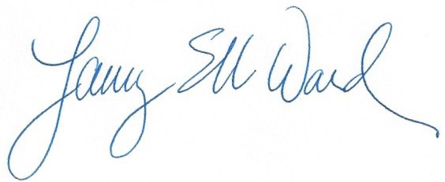

Laury Ward Secretary

