Schuyler County Industrial Development Agency
910 South Decatur Street, Watkins Glen, NY 14891
Meeting Minutes
November 3, 2021

Call Meeting to Order: The meeting of the Schuyler County Industrial Development Agency (SCIDA) was called to order at 5:00pm by Carl Taber.

Roll Call: | Hon. Carl Blowers  Carl Taber  John Terry  Margaret Lawrence  Mark Taylor  Kristin Van Horn  Laury Ward  Chad Hendrickson | Schuyler County Legislature  Chair  Vice Chairman  Treasurer  Member  County Planning  Secretary  Member
Excused: | Kevin Murphy | Retired
Guests: | Fonda Chronis  Kamala Keeley | Schuyler County  President, Three Rivers Development
SCOPED Staff: | Judy McKinney Cherry  Yvonne Zhao | CFO/CEO  Sr. Econ & Community Dev. Specialist

Public Comment
There was no public comment.

Minutes
A motion was made by Carl Blowers to approve the minutes of the October 2021 meeting, second by Laury Ward. Motion carried, unanimously.

Financial Statements
Judy McKinney Cherry reviewed October 2021 financials. There were minimal expenses in October.
A motion was made by John Terry to approve the October 2021 financial statements, second by Laury Ward. Motion carried, unanimously.
Amended: October 2021 financials were pre-reconciliation. The Treasurer Margaret Lawrence was not present at the November board meeting.

New Business

Kamala Keeley Presentation
Kamala Keeley presented on behalf of Three Rivers Development regarding a newly created website and marketing tool for the region. There was a great emphasis on workforce development and she called for Schuyler County to join the marketing effort carried out through Three Rivers Development.

ABO/PAAA Updates
Judy McKinney Cherry updated that data has been uploaded and SCIDA is legally compliant.

Committee Reports
Finance Committee – There was no meeting held.
Governance Committee – There was no meeting held.
Audit Committee – There was no meeting held.

Ongoing Business
Village of Marina Restaurant Lease – Judy McKinney Cherry updated on the status. A proposal was received for a 3-year contract; the County supports 1 year extension. The owners elected not to move forward with the lease and it will end in March 2022. The last payment is expected next summer, and IDA will work with the business owners on the transition.

Broadband – Mark Taylor updated on the status. First, Southern Tier Network is looking for pods of concentration of housing to do a demonstration project for broadband. Suggested Beaver Dams because their internet is poor. Second, there are no immediate plans going forward. However, the target on rural area from the new Infrastructure Bill can unlock some real potentials.

Camp Monterey – Judy McKinney Cherry updated that we have not yet received a draft agreement from the state.

Glen Beacon, LLC – Judy McKinney Cherry updated that the PILOT was approved and will work with the owner’s attorney to move forward.

Adjournment
A motion was made by John Terry to adjourn the meeting at 6:30 PM, second by Laury Ward. Motion carried, unanimously.

Respectfully submitted,
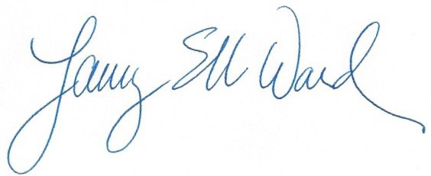

Laury Ward Secretary

